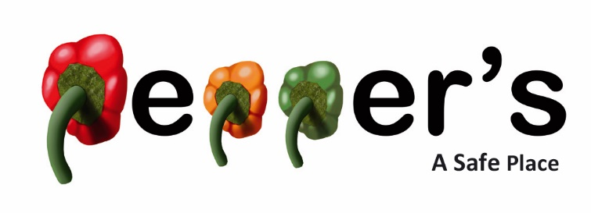
Have you been struggling with your mental health? Have you been feeling isolated, lonely or in need of a listening ear?

Pepper's- A Safe Place aims to provide anyone struggling with their mental health a space to relax, take some time out and chat with friendly volunteers and like minded individuals. We can offer a listening ear, a social space and a non-judgemental or pressurising environment.

Pop in for a cup of tea or coffee on one of your 4 adult drop-in sessions, these take place weekly on Tuesdays (10:30-12:30), Thursdays (13:00-15:00), Sundays (14:00-16:00) and in Melton on Wednesdays (14:00-16:00).

Our Parent and Baby Group in Oakham, after being closed for a couple of months over the holidays, will be re-starting on 2nd September for weekly sessions 10:00-12:00. This is a space for any parents or carers who are struggling with their mental health to bring their little ones, share experiences and feel welcome.

For anyone nervous about attending our sessions you are welcome to message us on 07714 503 556 or email info@peppersrutland.co.uk, we can answer any questions or set you up with a volunteer 1:1 to help you feel more confident before attending one of our drop in sessions.

