Community Litter Pick
Sunday 12 December 2021
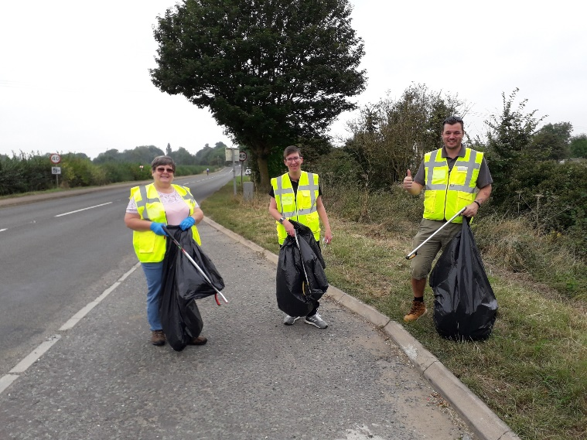
Following the success of our Community Litter Pick during the Great Big Green Week in September, we are organising another litter pick on Sunday 12 December, 10am to 12 noon. All are welcome. Meet at the bus shelter on the High St, outside Chater Lodge, at 10am, and bring gloves and suitable footwear. Litter picking equipment will be provided. We hope to arrange regular litter picks during 2022: please follow us on Facebook and Twitter for details of future events. For more information call David Lewis on 01780 721976.

