 | Support Force Headquarters  Royal Air Force Wittering
Notification of Aircraft Activity
night flying activity expected at RAF Wittering
Night flying with large aircraft is expected at Royal Air Force Wittering from Tuesday 15th March until the evening of Thursday 17th March inclusive.

Night flying will take place 1900 until 2300 (local time) as crews train with Night Vision Goggles. Operating under the cover of night is essential to modern military operations. Night Vision Goggles are a real tactical advantage and enable our crews to land and take-off safely during the hours of darkness.

Royal Air Force Wittering is reaching out to its neighbours and the nearby equestrian establishments to inform them of a change to the usual pattern of flying activity.

The Station is one of several that supports night flying; a variety of airfields and environments gives crews a breadth of experience and ensures that no single area is unduly burdened.

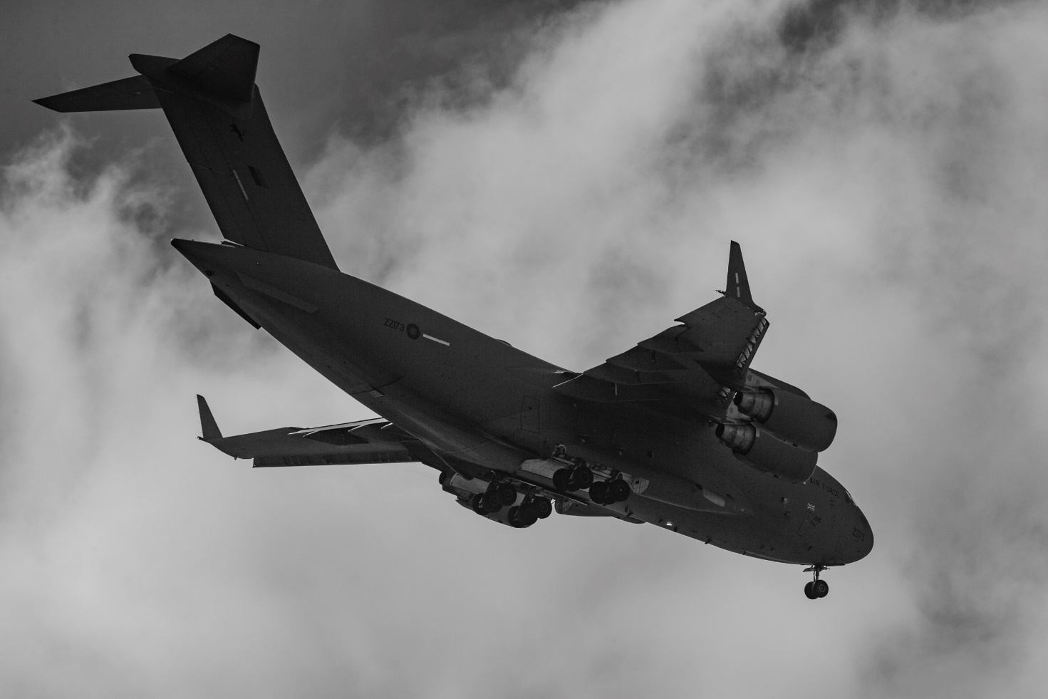

An RAF C-17 Globemaster at Royal Air Force Wittering.

