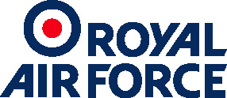 |  | Support Force Headquarters  Royal Air Force Wittering
Notification of Aircraft Activity
17 March 2021
night flying activity expected at RAF Wittering
Royal Air Force Wittering is reaching out to its neighbours and the nearby equestrian establishments to inform them of a change to the usual pattern of flying activity.

Night flying is expected at Royal Air Force Wittering in the week commencing Tuesday 22nd March until Thursday 24th March. Night flying will take place 1900 until 2300 (local time).

This represents a second week of Night Vision Goggle training for RAF transport aircraft crews. Wing Commander Maggie Boyle is the Deputy Station Commander at RAF Wittering. She said: “We would like to reassure our neighbours that, although this is the second week of night flying, we make every effort to keep disturbance to a minimum.”

The C-17 Globemaster is a long range, heavy-lift transport aircraft that can operate close to a potential area of operations for combat, peacekeeping or humanitarian missions. Operating under the cover of night is essential in modern military operations. Night Vision Goggles are a real tactical advantage and enable our crews to land and take-off safely during the hours of darkness.

Night Vision Goggle training is a method of conducting night flying without lights on an airfield. Crews wear equipment which enhances ambient light conditions, allowing the RAF to operate into hostile or sparsely populated areas.

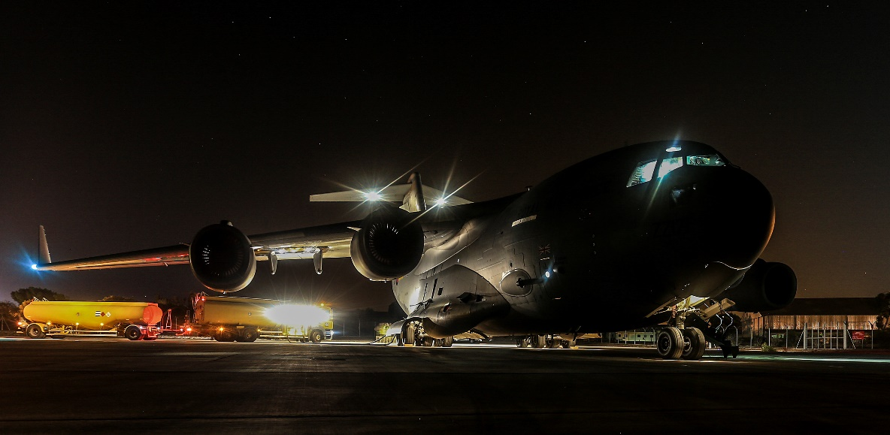

An RAF C-17 Globemaster at Royal Air Force Brize Norton

https://www.raf.mod.uk/our-organisation/stations/raf-wittering/

RAF Wittering is one of several stations that supports night flying; a variety of airfields and environments gives crews a breadth of experience and ensures that no single area is unduly burdened.

