KETTON CLIMATE ACTION

SURVEY


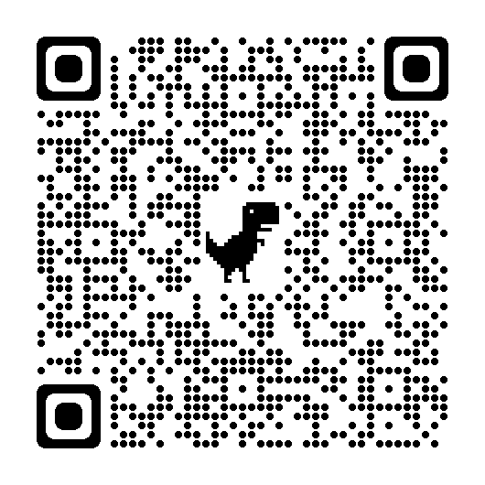

Tell us what you are interested in and what you would like to know more about.

Deadline for completion March 21st

https://https://docs.google.com/forms/d/e/1FAIpQLSelIAAfCpwbS7-rGXJmQDYVIu125lPz1DGdWMEqLXE6t6cFig/viewform

Follow Ketton Climate Action on Facebook and Twitter for details of future events.

